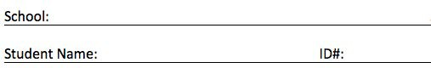

Columbus City School District

**MS Accelerated Math Practice Test**



A calculator is allowed and encouraged to be used all parts of this test. Avoid losing points due to simple math errors.

© 2016 Fluence Learning LLC. All Rights Reserved.

Licensed for use to Columbus City School District in accordance with contract. Not licensed for use after 09/30/2017.

Read questions 1 through 38 and select the best answer.

Mrs. Andretti is having new drapes made for her living room. The cost of the material is $15 per yard. The fee to make and hang the drapes is

**1**

$250. She uses the expression 15*x*

+ 250 to calculate the total cost of the drapes. What does the *x* represent in her expression?

1. the total cost of the material
2. the total cost of the drapes
3. the total yards of fabric used
4. the total amount of fabric she

Julie needs to make 4 gallons of fruit punch. She has these ingredients already.

●

**3**

1

5

8 gallons orange juice

●

3

4 gallon pineapple juice

●

1

2 gallon grape juice

The last ingredient she needs to add to make exactly 4 gallons is lime soda. How much lime soda does she need to add?

already has

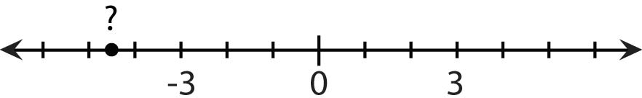A point is marked on the number line shown.

**2**

1. 1

8

1

1. 7

1

8

1. 1

2

8

1. 7

2

8

gallons gallons gallons gallons

Which of the following best names the location of the point?

**A.** –5.0

**B.** –4.5

**C.** –3.5

**D.** –1.5

Alina is 6 years older than Greg. Martin’s age is 2.5 times Alina’s age. Martin is 40. How old is Greg?

1. 10

**4**

1. 16
2. 14
3. 15

A hot air balloon leaves the ground and rises to an elevation of 1,100 feet. During the next 30 minutes, it descends 500 feet, rises 950 feet, descends 375 feet, and finally passes over a school. What is the elevation of the balloon when it passes over the school?

**5**

1. 1,025 feet
2. 1,100 feet
3. 1,175 feet
4. 1,550 feet

Robin is making floral arrangements for a party. Each arrangement has 8 roses and 10 carnations. Each carnation costs $0.75 and each rose costs $1.85. Which expression represents the total cost for one arrangement?

**6**

**A.** 8(0.75) + 10(1.85)

**B.** 10(0.75) + 8(1.85)

**C.** 8 + 10 + (0.75 + 1.85)

**D.** (8 + 0.75)(10 + 1.85)

The table shows how the length of a fish changes over time.

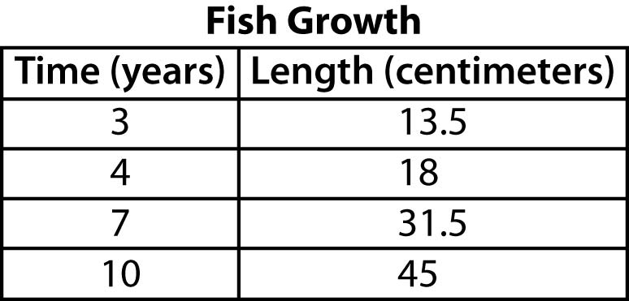

Which equation represents the relationship between *x*, the time in years, and *y*, the length in centimeters?

**7**

1. *y* = 4.5*x*
2. *x* = 4.5*y*

**C.** *y* = 13.5*x*

**D.** *x* = 13.5*y*

Kelly received two gift cards to her favorite store. One card was worth

**8**

$25 and the other was worth $40. She went shopping and chose 4 shirts for $9 each and 2 skirts for

$17 each. How much will she owe after she uses the cards?

**A.** $5

**B.** $15

**C.** $33

**D.** $39

Use this coordinate plane to help answer the question.

**9**

**10**

Justin runs a restaurant and is training a new line cook to cook large batches of rice. He tells the cook that the amount of raw rice is proportional to the amount of

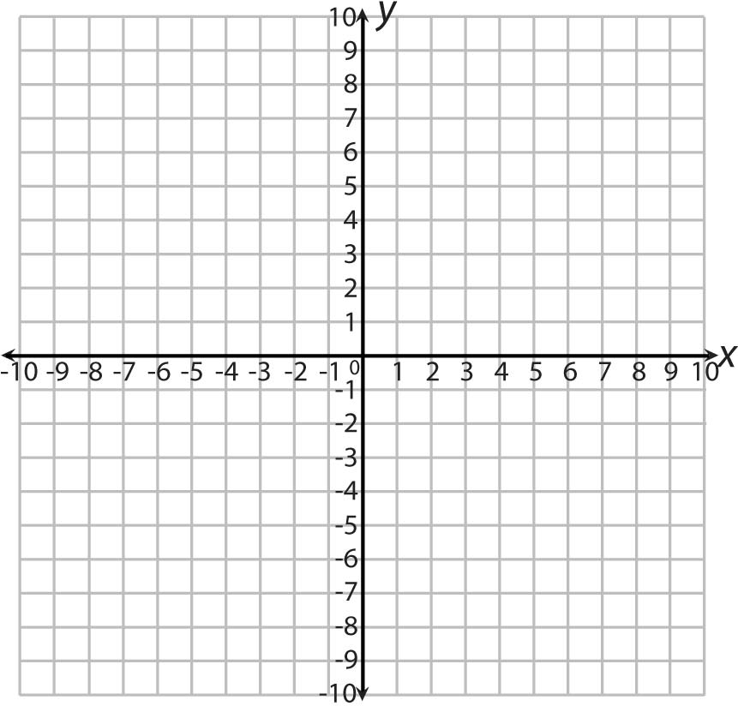water. He needs to use 11 1

**4**

cups of

water with 6 cups of raw rice, and

3 cups of water with 4 2

8

**3**

**4**

cups of

Which two points belong to the graph of a proportional relationship?

**A.** (0, 2) and (2, 4)

**B.** (1, 2) and (3, 4)

**C.** (0, 2) and (2, 0)

**D.** (1, 2) and (3, 6)

raw rice. Which equation represents the number of cups of water, *w*, to use with *r* cups of raw rice?

1. *w* = 21 *r*

4

1. *w* = 8 *r*

15

1. *w* = 2*r*
2. *w* = 15 *r*

8

Karen is planting a garden as shown.

**11**

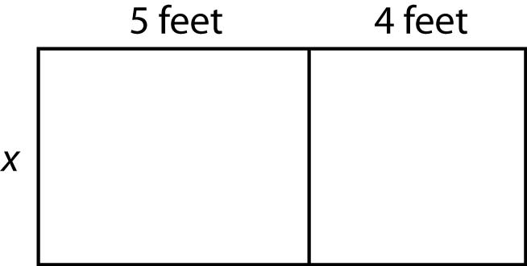

She wrote the expression *x* (5 + 4) find the area of her garden.

Which expression is equal to Karen's expression?

1. 5*x* + 4*x*
2. 5*x* + 4
3. 20*x*
4. *x* + 9

Stephanie is giving a presentation to a new client. It took her 17 1

**12**

**3**

minutes to finish a 13-slide

presentation. She took the same amount of time on each slide. How long did she spend on each slide?

It is customer appreciation week at Jim’s Shoe Outlet, which means all customers are given a 20% discount on all items. A customer comes in with a birthday coupon for an additional 10% off any one item.

The customer buys 3 pairs of shoes

**14**

1. 3 4

minute

for $120.00 each. After the two discounts, how much does the customer pay?

1. 1 minute

**A.** $81.60

1. 1

1

3

1. 1

1

2

minutes minutes

**B.** $259.20

**C.** $278.40

**D.** $288.00

Mr. Swenson has 455 sheets of graph paper for his class. He distributes the paper as evenly as possible among his 26 students.

**13**

How many sheets are left over?

1. 5
2. 7
3. 13
4. 17

Petey’s Shirt Company can make 240 T-shirts in a day. After buying new machines, the company is able to make 456 T-shirts in a day. By what percent did the production increase?

**A.** 9%

**15**

**B.** 47%

**C.** 53%

**D.** 90%

Which of the following situations is represented by the expression

**16**

**54 − 3*n* ?**

1. Quentin had $54. He gave $3 to his sister and $3 to his uncle. How much money does Quentin have left?
2. Penelope had 54 paperclips and used 3 paperclips for each project. How many projects did Penelope have?
3. Nathan’s age is 54 less than 3 times Olga’s age. How old is Nathan?
4. Maria had $54. She bought 3 books that each cost the same amount. How much money does Maria have left?

Mike has $40, which is $6 more than twice the amount of money that Karly has. How much money does Karly have?

**17**

**A.** $14

**B.** $17

**C.** $23

**D.** $74

A scientist has 42.359 grams of copper. She uses 3.08 grams in an experiment. How many grams of copper are left?

1. 11.559 grams

**19**

1. 38.559 grams
2. 39.279 grams
3. 42.051 grams

Joseph buys a gallon of milk every 6th day and a box of cereal every 8th day. He bought both items today. In how many days will he buy both items together again?

**20**

1. 14
2. 18
3. 32
4. 24

Which expression is NOT equivalent to 8*x* ?

**18**

**A.** 10*x* − 2*x*

**B.** 2 + 6*x* − 2(1 − *x* )

**C.** 7*x* + 1

**D.** 10 + 8*x* − 10

John is comparing his workers’ production for the day. The ratios of items produced to time in hours are shown.

**21**

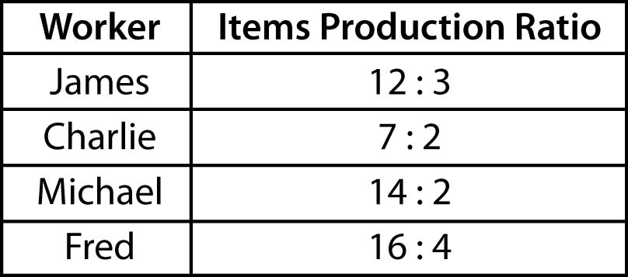

Which two workers have equivalent ratios?

1. Michael and Fred
2. Charlie and Michael
3. James and Charlie
4. James and Fred

David went for a run in his town.

* + He ran from his house to the school, which is 1.22 miles.

**23**

* + Then he ran 3 laps around the school track. Each lap is 0.25 miles.
  + Then he ran halfway to the gas station. The distance from the school track to the gas station is

2.68 miles.

* + Finally he ran straight home, which is 0.49 miles.

What is the total distance David ran?

1. 3.8 miles
2. 4.64 miles
3. 5.14 miles
4. 6.3 miles

The volume of a cube is calculated by multiplying all three side lengths. If a cube measures 16 centimeters on each side, which expression can be used to calculate the volume?

**22**

**A.** 161

**B.** 162

**C.** 163

**D.** 164

Lin is traveling from Japan to several other countries. The conversion table shows exchange rates between different currencies.



What is the rate of yen per Indian rupee?

**24**

**B.** 0.63

**C.** 1.58

**D.** 1.69

Alex played basketball 20 minutes longer on Tuesday than she did on Monday. She played for a total of 110 minutes for both days. Which equation can be used to find the number of minutes Alex played on Monday?

**25**

**A.** 2*x* + 20 = 110

**B.** *x* + 20 = 110

**C.** 2(*x* + 20) = 110

**D.** 20*x* = 110

Kyle wrote this equation to represent a story problem.

**26**

3 • −$4 = −$12

Which story problem matches Kyle’s equation?

1. Each week for 3 weeks, Kyle borrowed $4 from his brother. How much money did Kyle owe at the end of 3 weeks?
2. Kyle earned $3 the first week and loaned $4 to his brother the second week. How much money did Kyle have at the end of the second week?
3. Each week for 3 weeks, Kyle earned

$4 for helping his brother mow the lawn. How much money did Kyle have at the end of 3 weeks?

1. Each week for 4 weeks, Kyle borrowed $3 from his brother. How much money did Kyle owe at the end of 4 weeks?

Gary works at a store on the weekends. Last weekend, he earned

$112 for working a total of 14 hours. How much did Gary earn per hour?

**27**

1. $7 per hour
2. $8 per hour
3. $12 per hour
4. $14 per hour

A factory produces 5,000 tablet computers in 4 days, as shown in the double number line below.

**28**

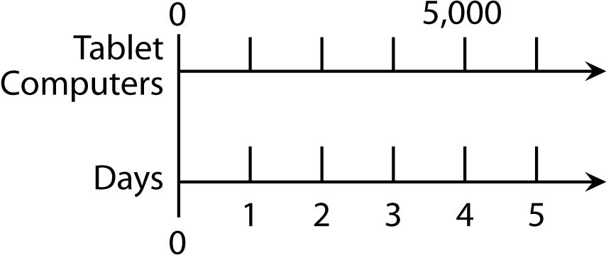

At this rate, how many tablet computers will the factory produce in 5 days?

1. 1,250 tablet computers
2. 6,250 tablet computers
3. 20,000 tablet computers
4. 25,000 tablet computers

What is the value of 5 + 5 · 34 ? A. 810

**29**

**B.** 410

**C.** 65

**D.** 120

Which word problem can be solved by the equation below?

**30**

**3 ÷ 3 = □**

Jerome uses the formula *I* = *prt* to find *I*, the interest earned, when he saves *p*, the principal of $456, for *t* years at a rate, *r*, of 3%. What is the value of *I* when *t* = 2?

**A.** $13.68

**31**

**B.** $27.36

**C.** $469.68

**D.** $483.36

The gas tank in Mr. Mackie’s car

**32**

**4 8**

holds 15 1

**5**

gallons of gas. How many

1. Jane has 3

ft of ribbon to trim

gallons of gas are in the tank when

8

candle holders as gifts. She uses 3

4

ft of ribbon for each candle holder. How many candle holders can Jane trim?

**it is 1**

* 1. 3

**4**

3

5

* 1. 3

3

4

full?

1. Jane has 3

8

ft of ribbon to trim

1. 3 4

candle holders as gifts. She buys 5

3

another 3 ft of ribbon for another

4

1. 19 20

project. How many feet of ribbon

does Jane have now?

1. Jane has 3

4

ft of ribbon to trim

candle holders as gifts. She uses 3

8

ft of the ribbon for another project. How many feet of ribbon does Jane have now?

1. Jane has 3

4

ft of ribbon to trim

candle holders as gifts. She uses 3

8

ft of ribbon for each candle holder. How many candle holders can Jane trim?

Billy was standing on a diving board that was 4 feet above the water. He dove into the pool which was 8 feet deep and touched the bottom.

**33**

Which statement accurately describes this situation?

1. If 0 represents the height of the diving board, then +4 represents the water level and –8 represents the bottom of the pool.
2. If +4 represents the height of the diving board, then 0 represents the water level and –8 represents the bottom of the pool.
3. If 0 represents the height of the diving board, then 4 represents the water level and 8 represents the bottom of the pool.
4. If +8 represents the height of the diving board, then 0 represents the water level and –4 represents the bottom of the pool.

Kalley has a bag with these candies in it.

**34**

* + 4 orange candies
  + 6 grape candies
  + 3 lemon candies

Which of the following is a ratio that describes the candies in the bag?

1. For every 1 lemon candy, there are 2 grape candies.
2. There are 2 more grape candies than orange candies.
3. There are more orange candies than lemon candies.
4. There are a total of 13 candies.

Keely and Grayson played a board game. Keely scored 128 points, which was 4 times as many points as Grayson scored. How many points did Grayson score?

**A.** 132

**35**

**B.** 32

**C.** 512

**D.** 124

It costs $150 to rent a party room at Pizza-n-Games, plus $6 per person for pizza and $5 per person for game tickets. The expression shown gives the total cost for *n* people.

**36**

**150 + 6*n* + 5*n***

Evaluate the expression to find the cost for a party of 15 people.

**A.** $330

**B.** $161

**C.** $191

**D.** $315

— 16 — Go On

Mr. McGill earns $40 an hour working *h* hours each day for 5 days. Which expression represents the total amount of money he earns?

**37**

**A.** 40*h* + 5

1. 40*h*
2. 40*h* 5
3. 200*h*

Connor finished a race in 48.72 minutes. Julie finished the race ahead of Connor. Which time can be Julie’s total time for the race?

**38**

1. 48.29 minutes
2. 48.81 minutes
3. 48.72 minutes
4. 49.05 minutes

— 17 —

**39**

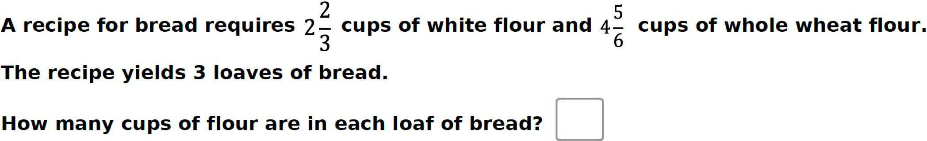

The table shows the change in the value of a certain stock each week during a 4-week period.

**40**

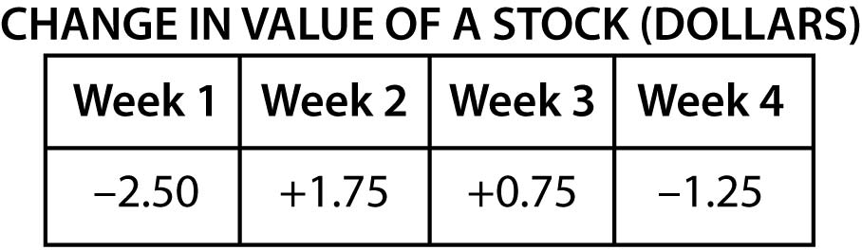

**Drag the numbers below into place so that they are in order from greatest to least.**

**Greatest Least**



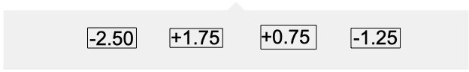

**The ratio of boys to girls in a classroom is 3 to 2.**

**41**

**In the table below, mark TRUE if the given ratio is equivalent to 3 to 2. Mark FALSE if the ratio is not equivalent to 3 to 2.**

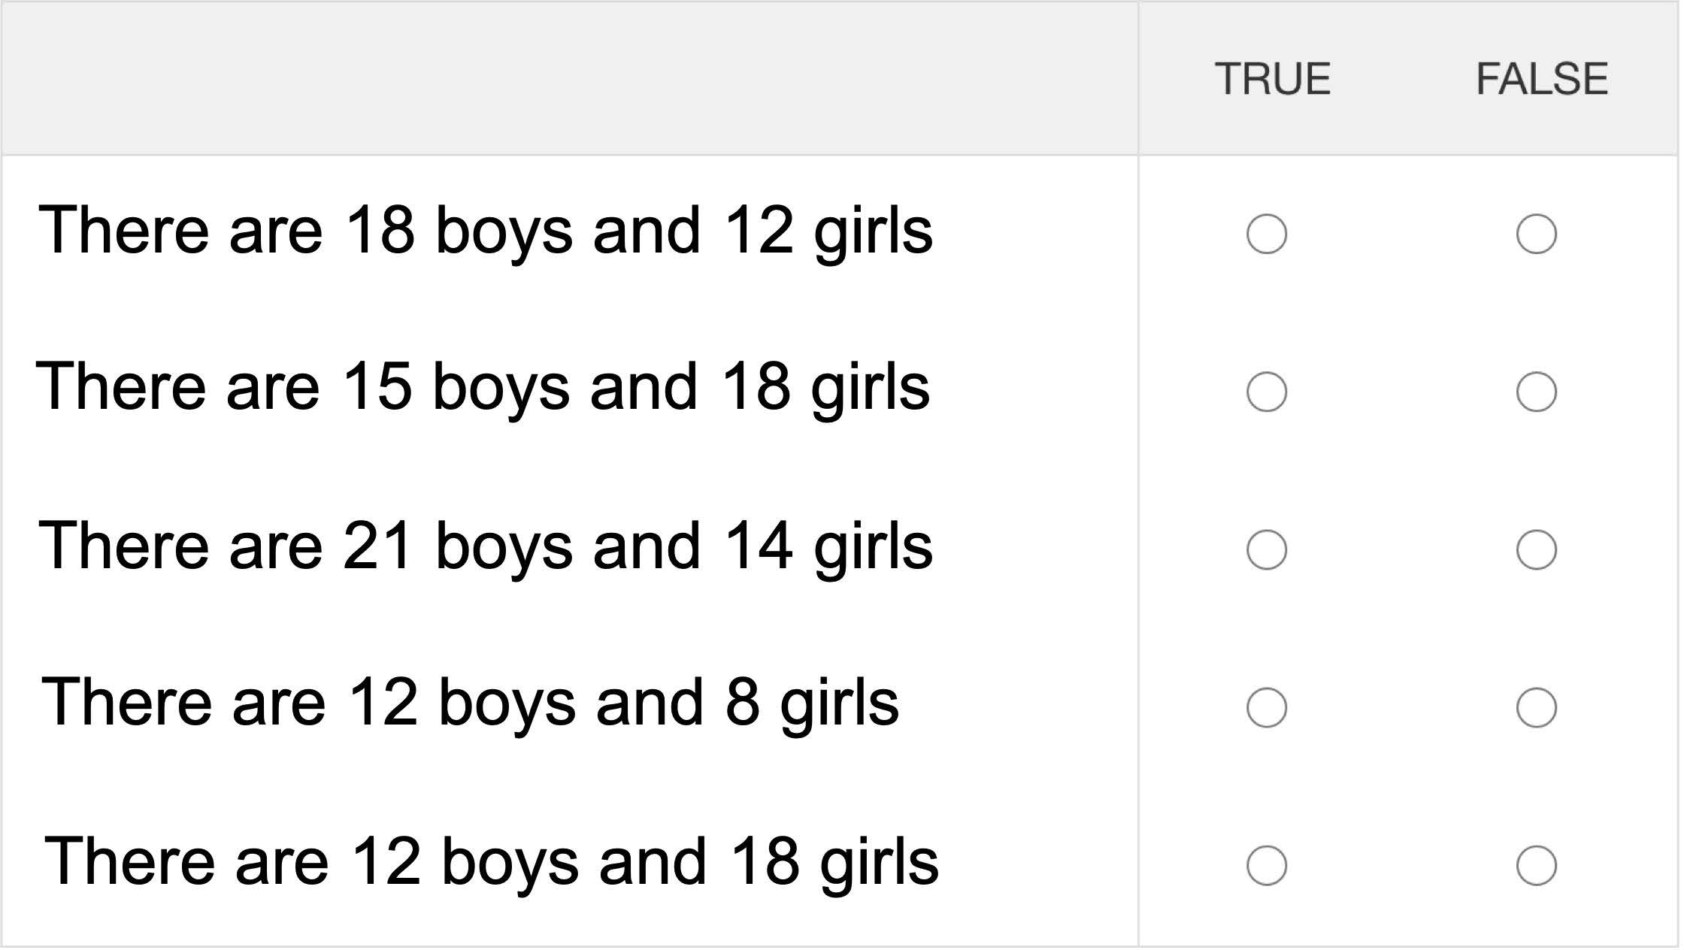

Mr. Shuler and Ms. Miles buy the same kind of muffins at the bakery. Mr. Shuler buys 6 muffins for $4.50.

**42**

Ms. Miles spends a total of $6.75 for the muffins she buys.

How many muffins does Ms. Miles buy?



**Store X charges $112 for 5 gallons of blue paint. Store Y charges $174 for 8 gallons of the same paint. Find the price per gallon for each store.**

**43**

**Store X: $ ** **per gallon**

**Store Y: $ ** **per gallon**

**A customer buys 15 gallons of blue paint at Store X.**

**How much will the paint cost? $**